Statement of Work

Dialogs & Controls

# Goal

Implement dialogs and controls using to defined design and UX.

# Details

* Controls must be in separate classes so we can reuse them in other dialogs
* Controls need to provide methods and events that will be defined (i.e. “on click”, “on load”)
* The solution should be provided in WPF
* Implementation is restricted up to .Net 4.0 (again, if higher really drops development time, we can talk)
* There could be some changes during development, but the following describe the scope of the task
* Implementation must be based on “pixels” and not “points”, so the dialogs will look the same in all resolutions (smaller on high-res and bigger on low-res, but the proportions are exactly the same).
* All code must be supplied to Covertix

# Dialogs & Controls

## Basic Dialog

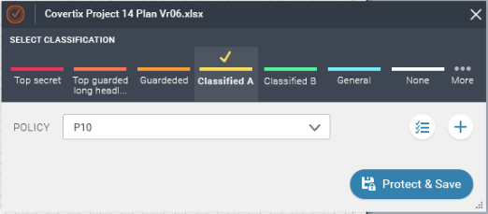

* Under the label "select classification" there are buttons (being generated in runtime using a provided function to add "classification button").
* a "policy selection" drop down menu
* "create new classification" button (button with "+" sign)
* "choose existing policy" button (button with "V and lines", to the left of the "+")
* "protect and save" button

## Clicking “New Classification” Button

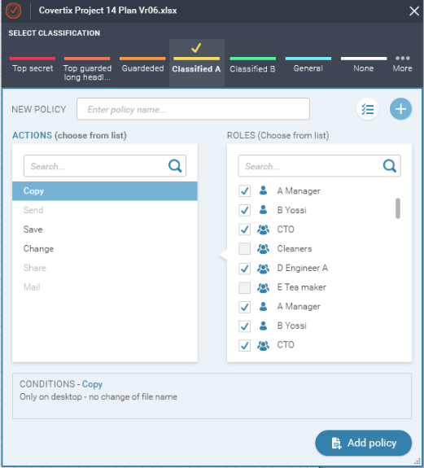

* 2 list boxes with search (and auto complete)
* a box with text
* "add policy" button (should be same control as "protect and save")

## Multiple Classification

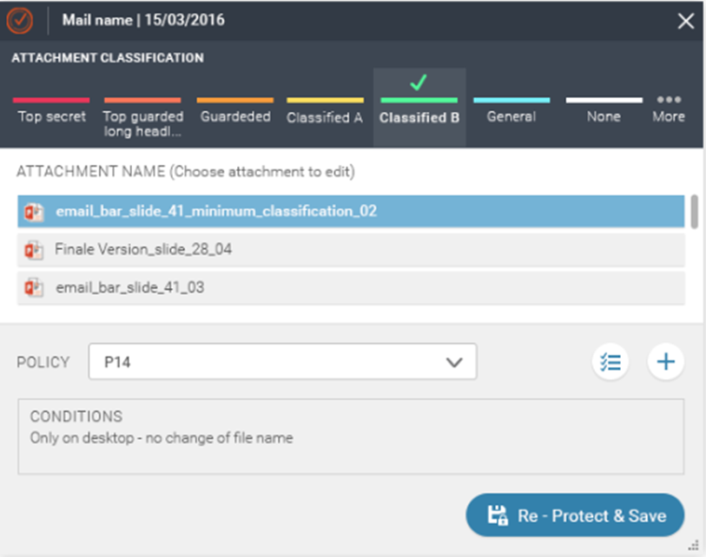

Same as the basic dialogs, but this dialog is being displayed when choosing multiple files or attachments.

Clicking each file fills the lower part of the dialog with the relevant data.

## Clicking "choose existing policy" button

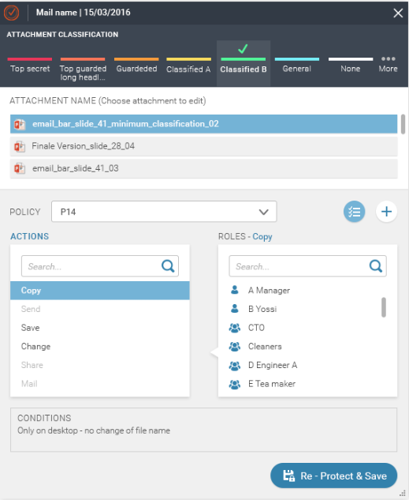

# Error Handling

Errors must be either thrown to the caller, or be handled. Handled exceptions must be traced to DebugView (OutputDebugString function) to allow us to debug and find future errors.

# Development Language

The solution must be implemented in C# using .NET 4.0 or lower. We prefer not to use WPF unless it really drops development time

# Coding Standards

The code must be documented and must not crash. All strings should be placed in string table (no hardcoded strings) to support future translation of the dialogs

# 3rd party libraries

In case the solution contains any 3rd party libraries, we must know and approve each library upfront to make sure that licenses are not being broken. Also we might need to modify our product “about” statement accordingly.

# Acceptance Criteria

The code will be tested and approved by Covertix QA department on the following products:

* Microsoft Outlook, Word, Excel, PowerPoint 2010/2013
* Acrobat Reader 9/10/11
* Windows 7/8 (Maybe 10)
* Different Resolutions

# Milestones

* Solution should be provided within around 2 weeks from the beginning of development
* Within 1 month from the beginning of development the integration must be over
* QA sessions begin after the final integrated solution is being provided

# Support

High priority support (attention within up to 1 day) must be provided at least until the integration and QA sessions on the solution are over (3 months from date of final version delivery). Also we expect support at least 1 year from delivery date (i.e. acceptance date) to handle any issues occur at clients